Chapter 2, Problem 55.

Calculate I_{o} in the circuit of Fig. 2.119.
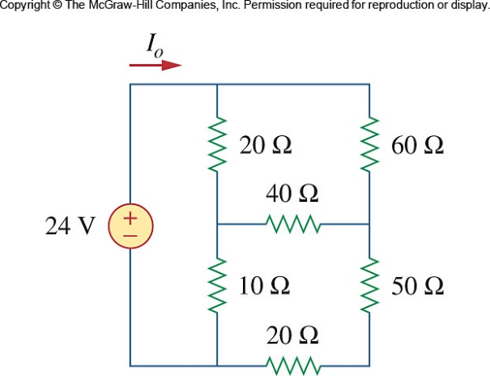

Figure 2.119
For Prob. 2.55.

